**CONFERENCE MANAGEMENTSYSTEM**

**Use case diagram:**

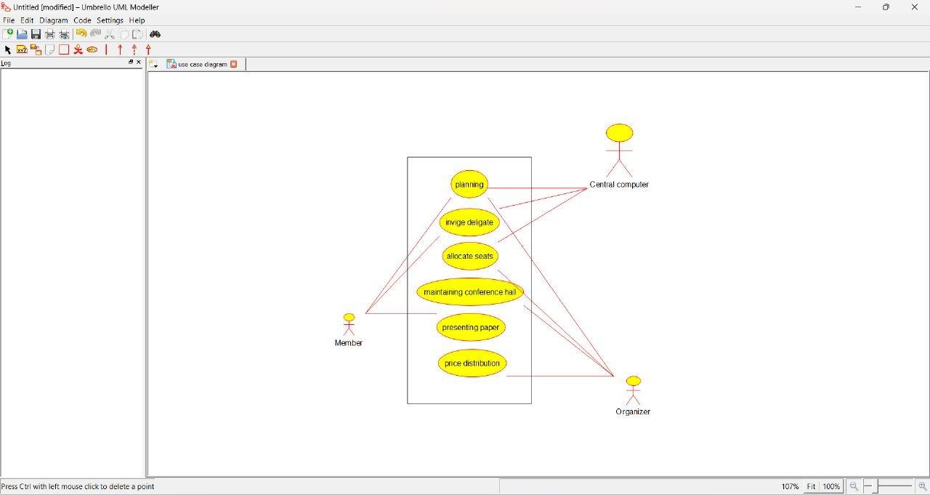

**Class diagram:**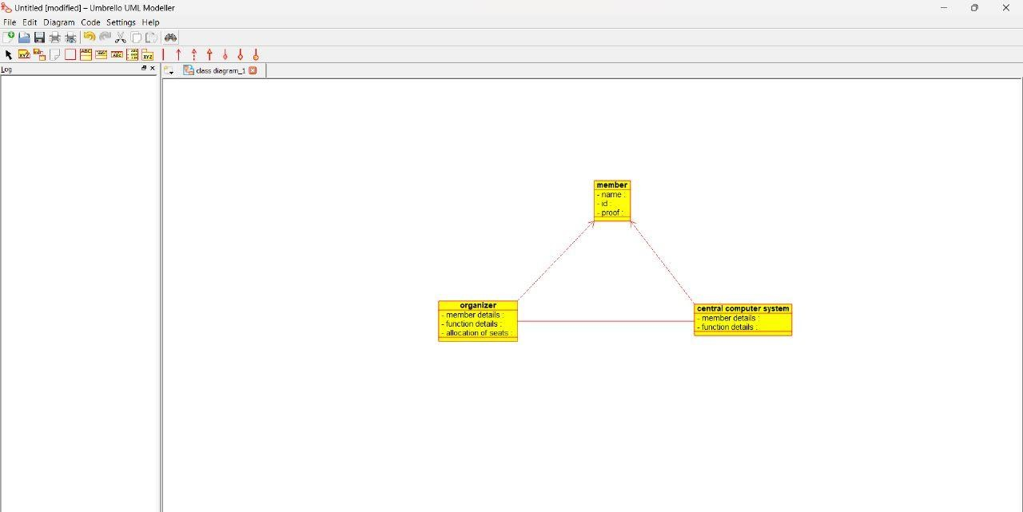

**ACTIVITY DIAGRAM:**

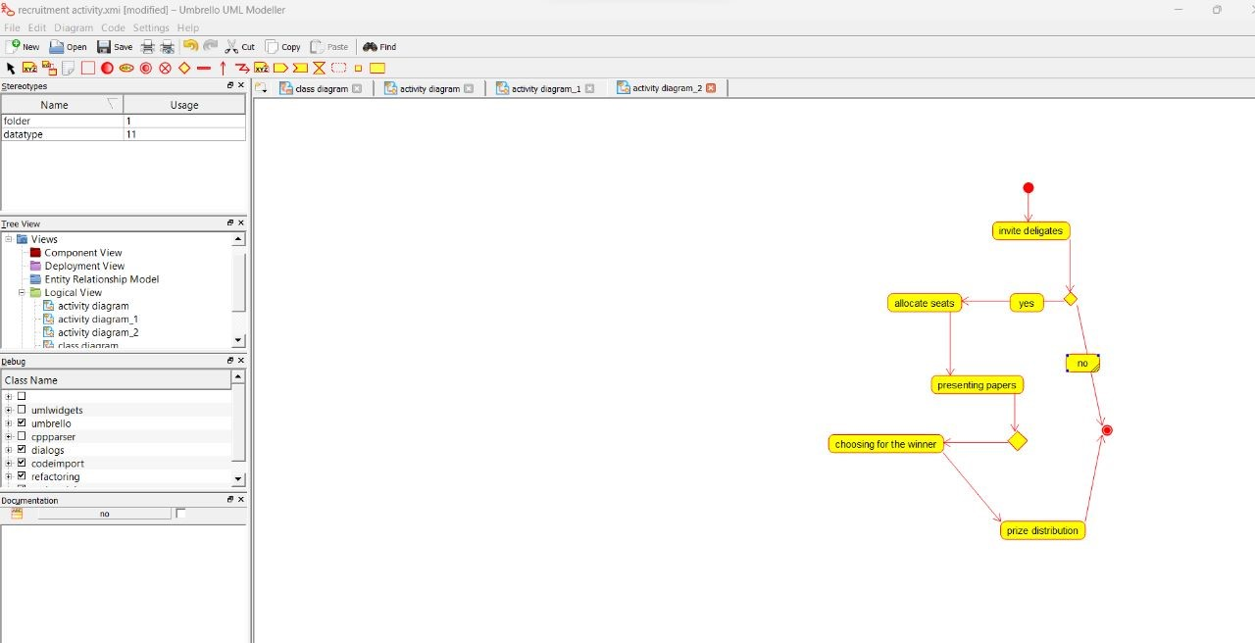

**SEQUENCE DIAGRAM:**

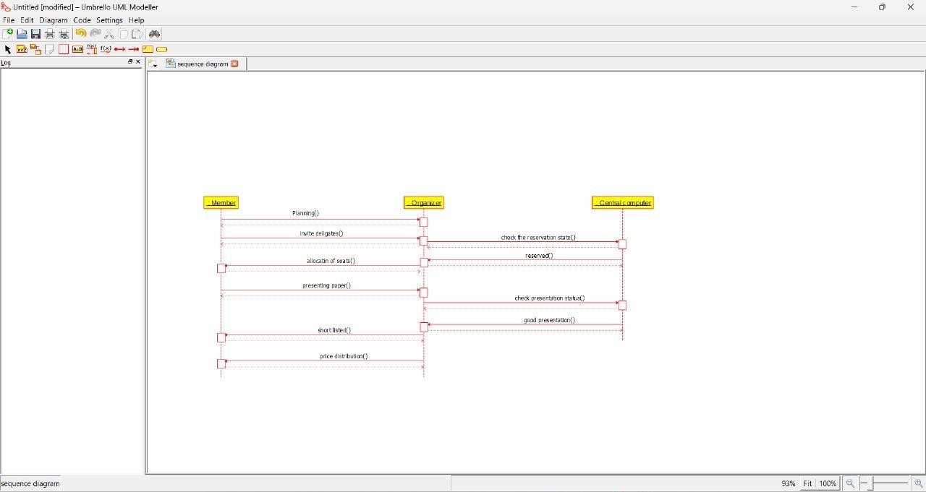

**FOREIGN TRADING SYSTEM**

**USE CASE DIAGRAM:**

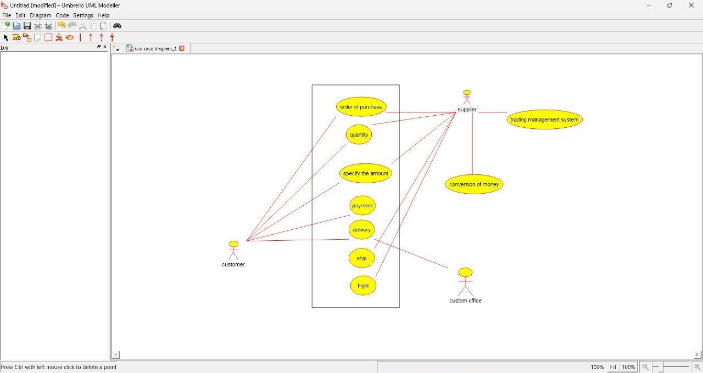

**CLASS DIAGRAM:**

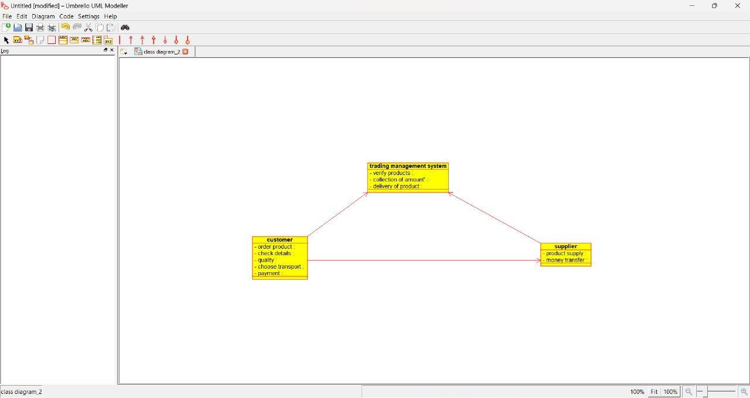

**ACTIVITY DIAGRAM:**

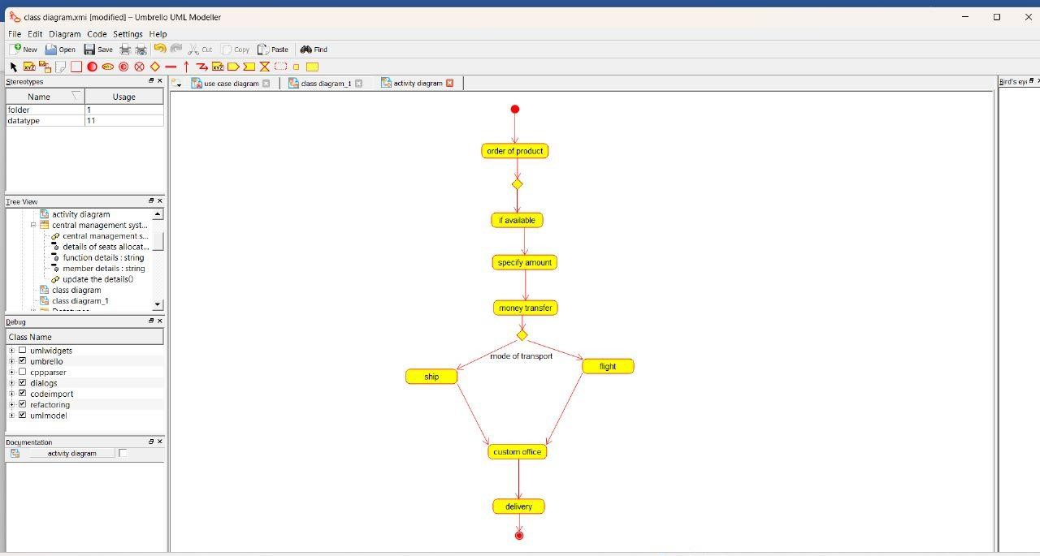

**SEQUENCE DIAGRAM:**

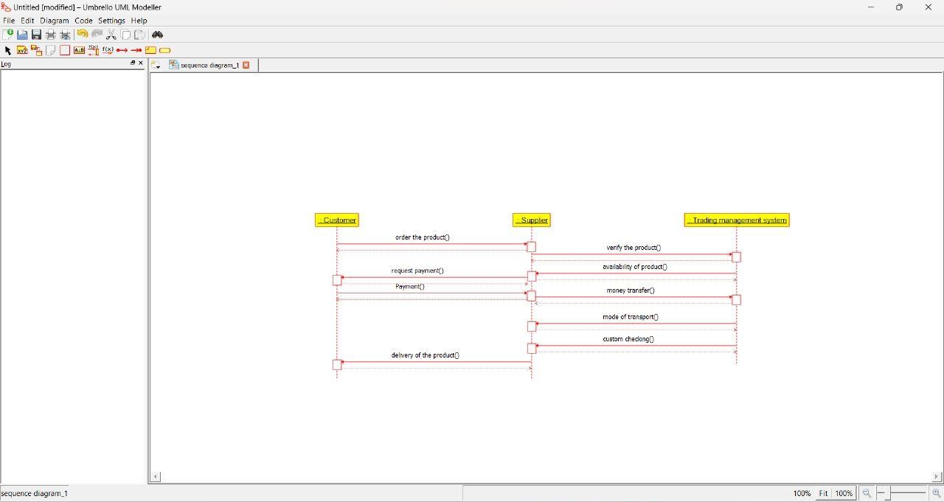

1. **BPO MANAGEMENT SYSTEM USE CASE DIAGRAM:**

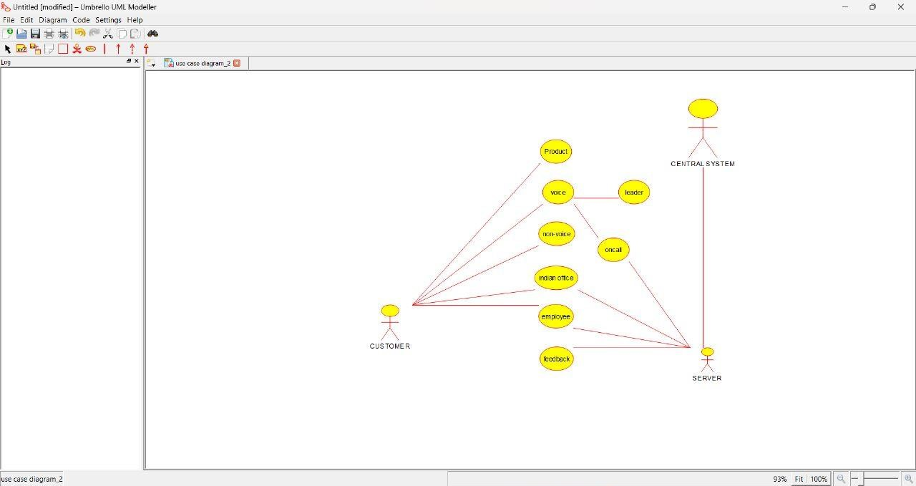

**ACTIVITY DIAGRAM:**

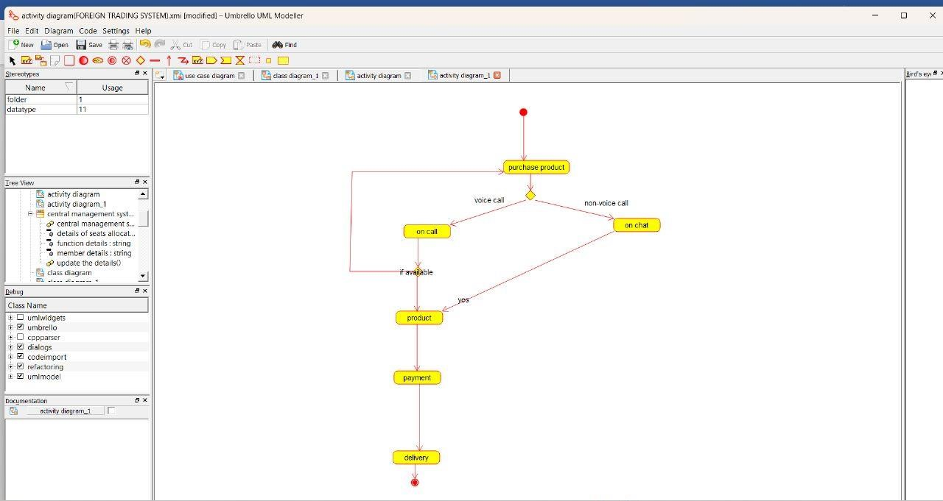

**SEQUENCE DIAGRAM:**

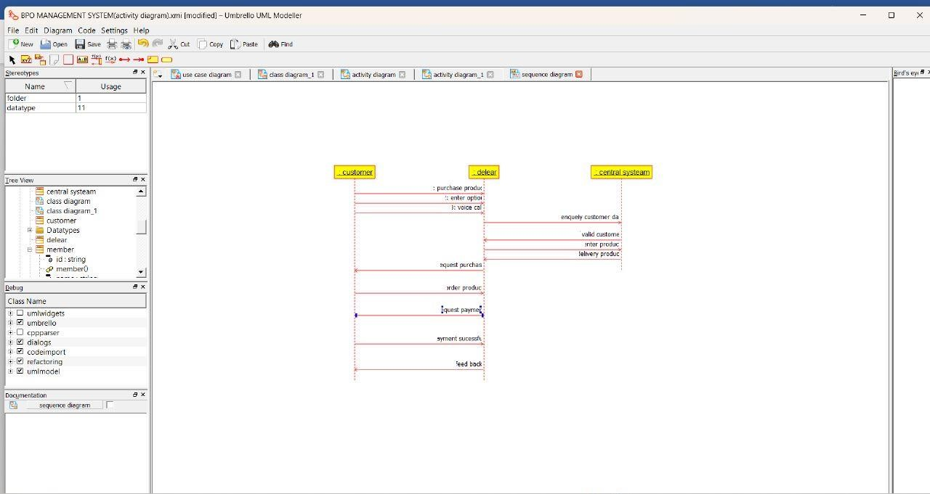

1. **E-COMMERCE REGISTRATION SYSTEM USE CASE DIAGRAM:**

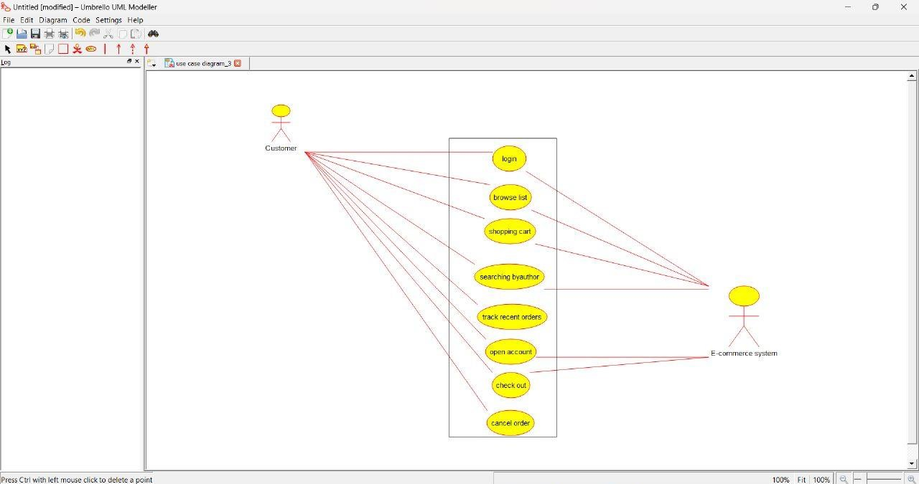

**ACTIVITY DIAGRAM:**

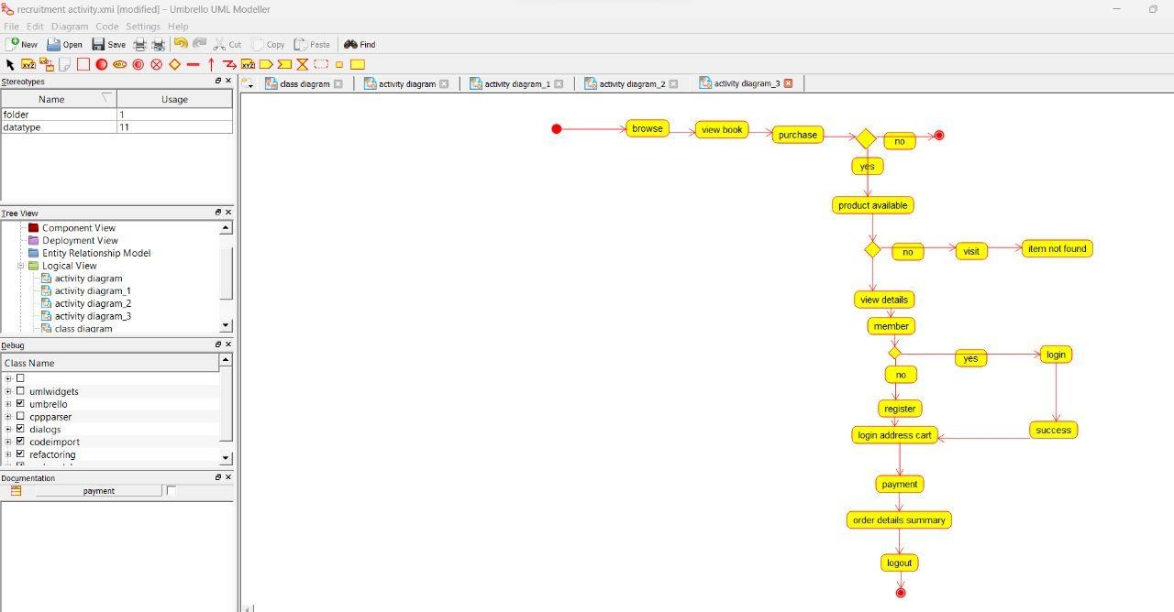

**SEQUENCE DIAGRAM:**

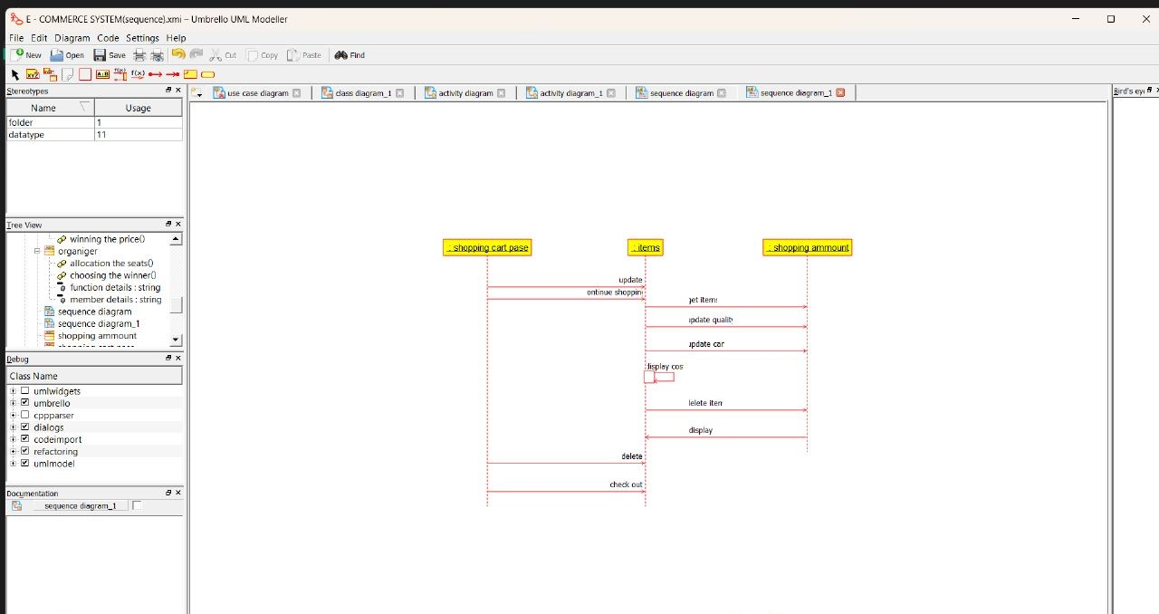

1. **BLOOD BANK REGISTRATION SYSTEM USE CASE DIAGRAM:**

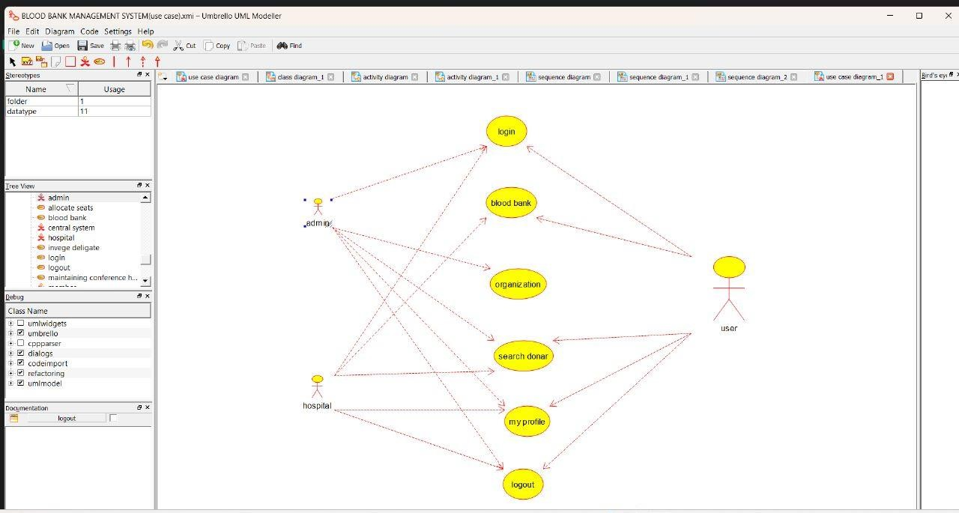

**ACTIVITY DIAGRAM:**

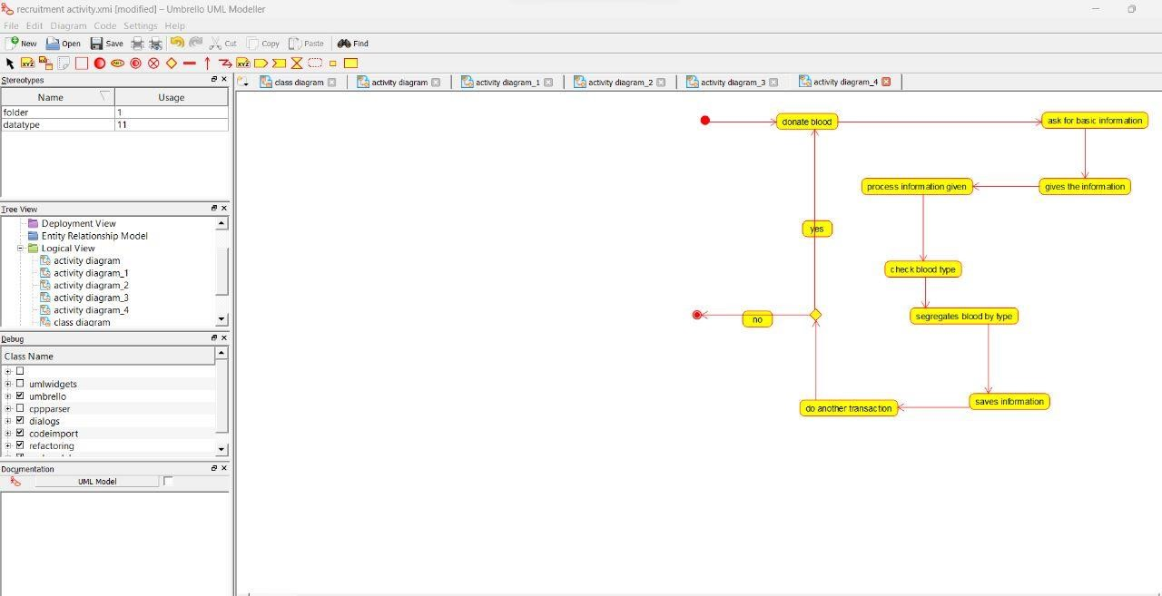

**SEQUENCE DIAGRAM:**

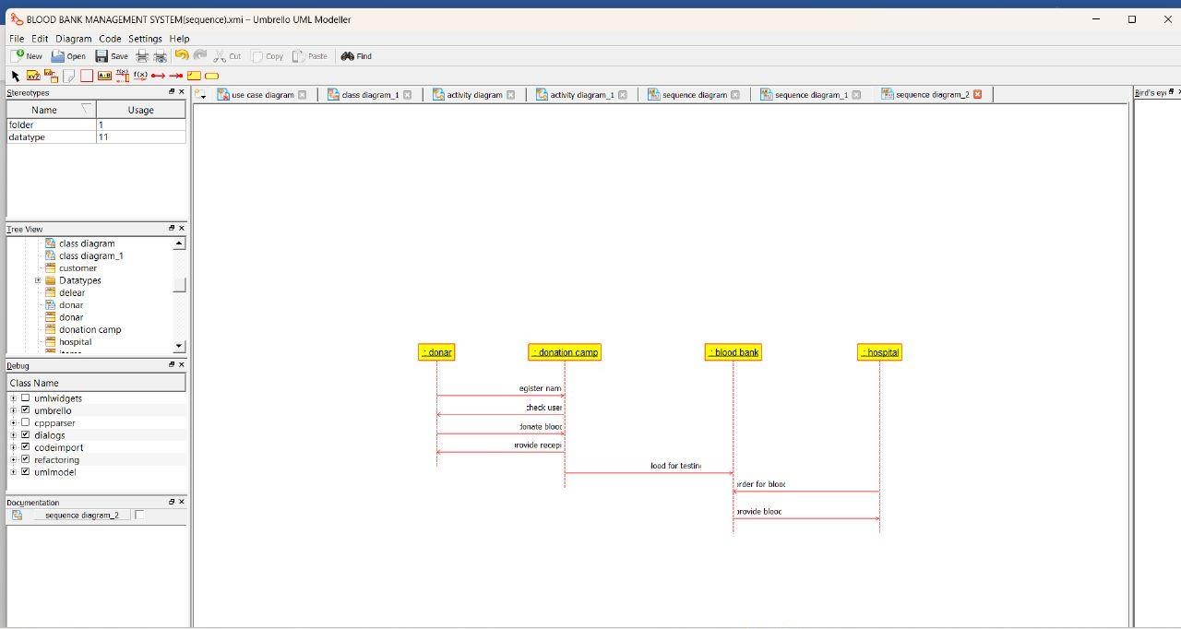

1. **ONLINE INTERNSHIP REGISTRATION SYSTEM USE CASE DIAGRAM:**

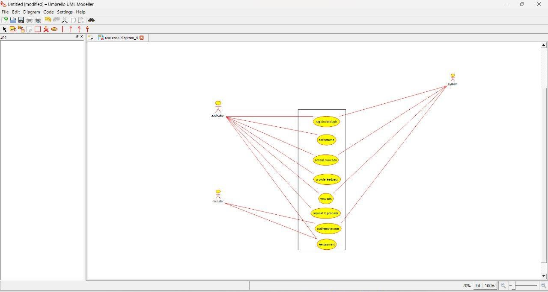

**ACTIVITY DIAGRAM:**

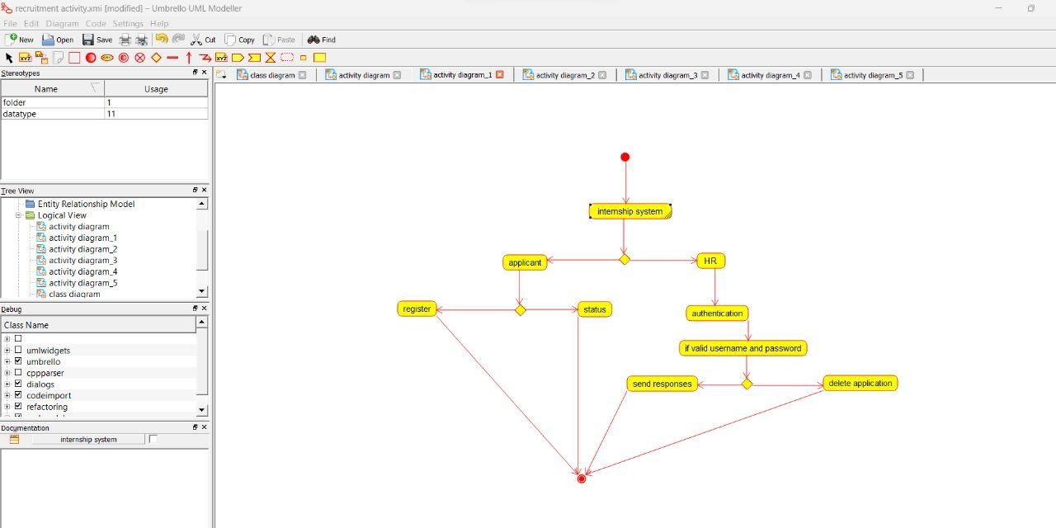

**SEQUENCE DIAGRAM:**

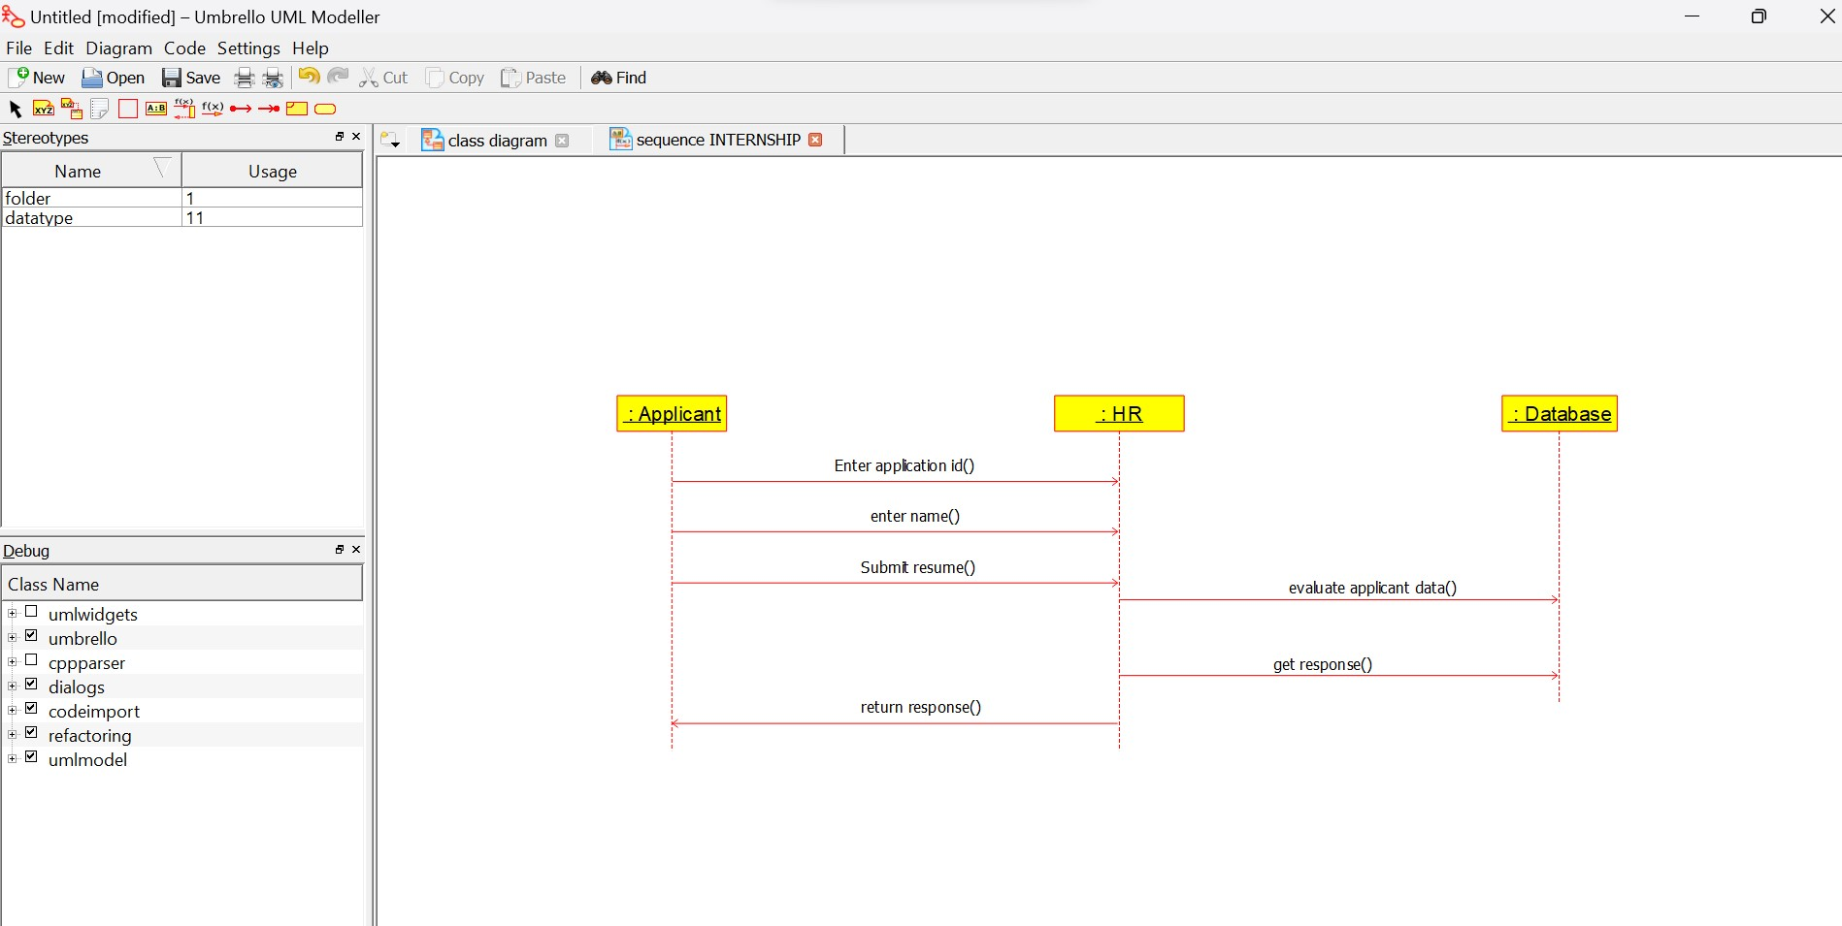

1. **VEHICLE REGISTRATION SYSTEM USE CASE DIAGRAM:**

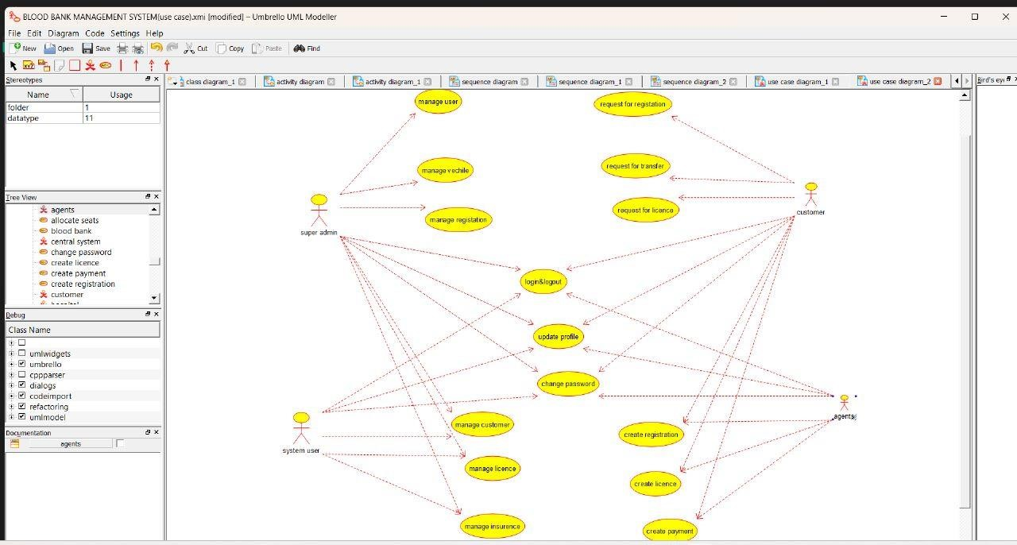

**ACTIVITY DIAGRAM:**

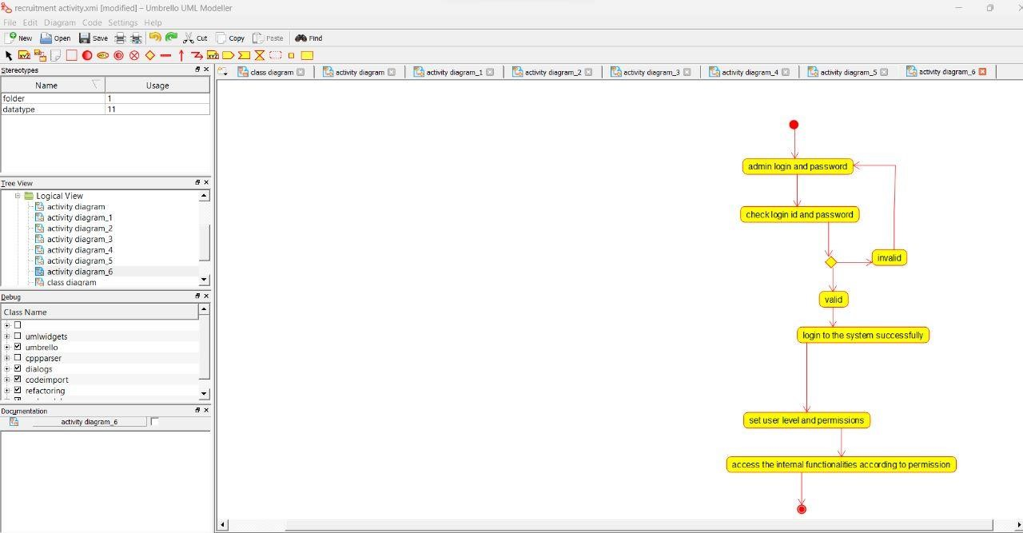

**SEQUENCE DIAGRAM:**

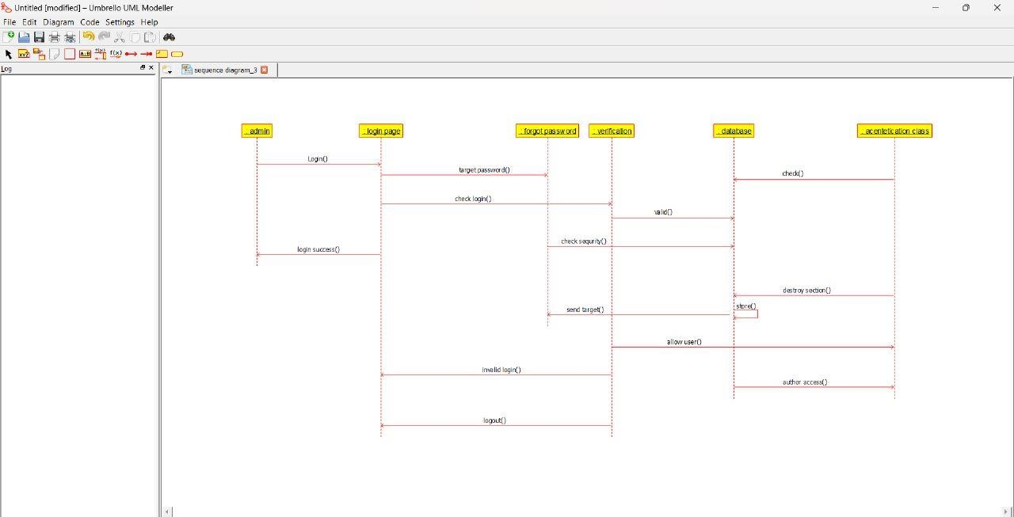

1. **FOOD ORDER SYSTEM USE CASE DIAGRAM:**

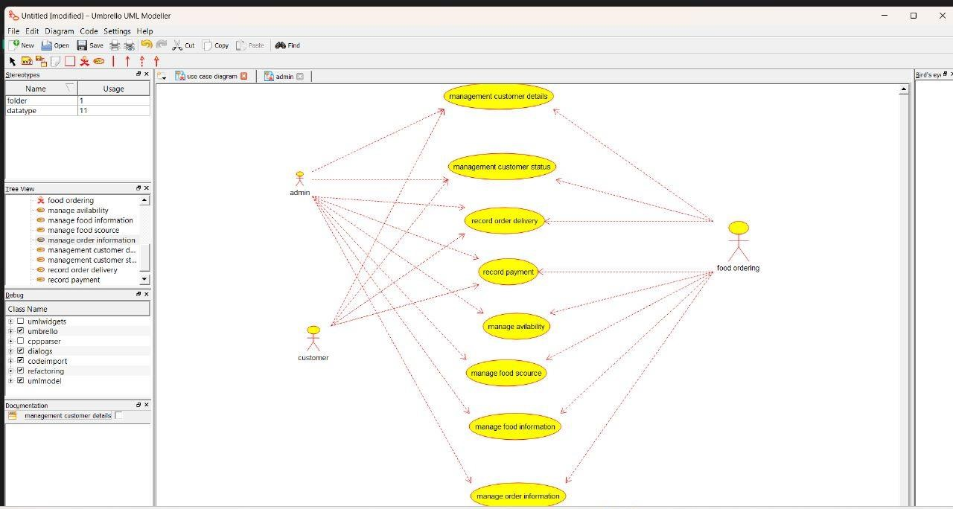

**ACTIVITY DIAGRAM:**

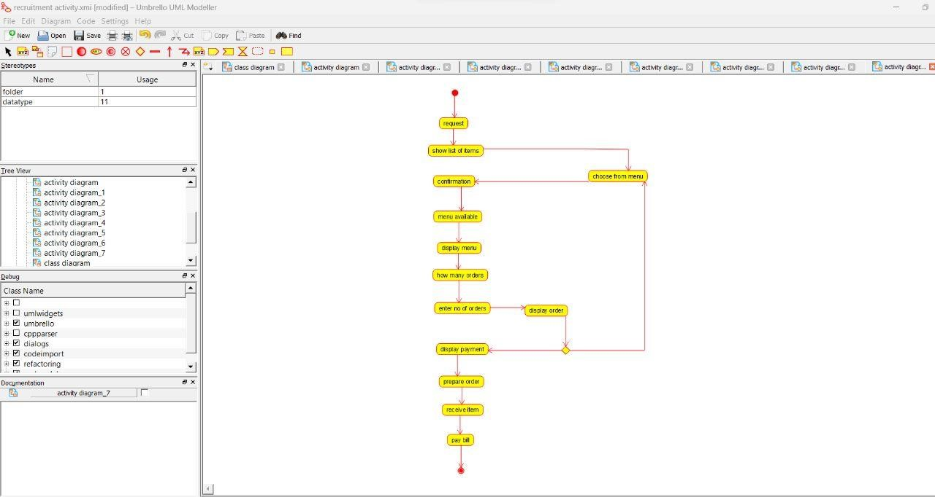

**SEQUENCE DIAGRAM:**

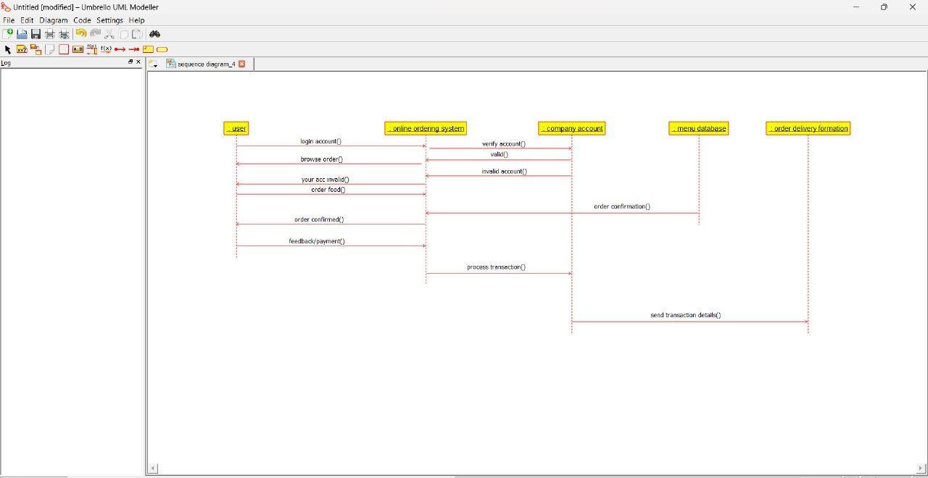

1. **HOME APPLIANCE CONTROL SYSTEMS (HACS) USE CASE DIGRAM:**

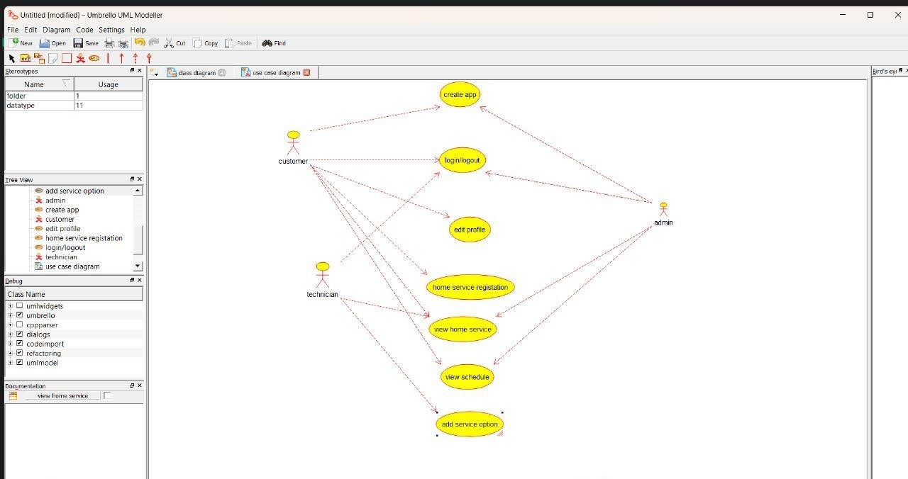

**ACTIVITY DIAGRAM:**

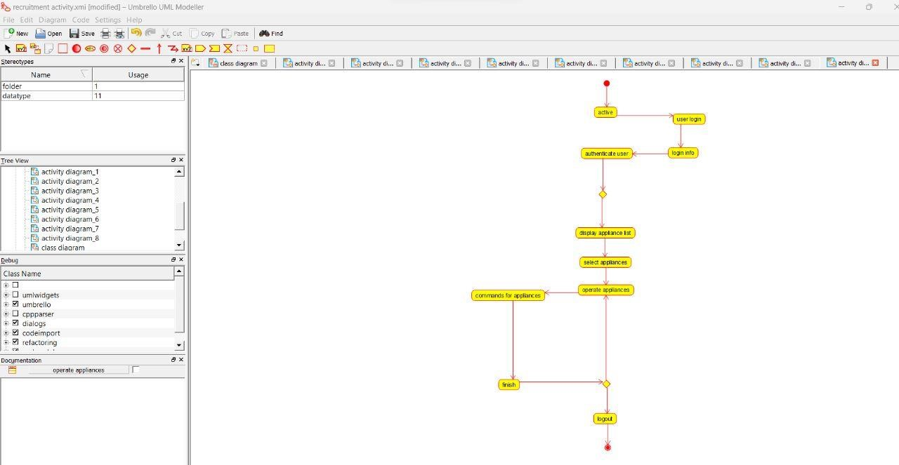

**SEQUENCE DIAGRAM:**

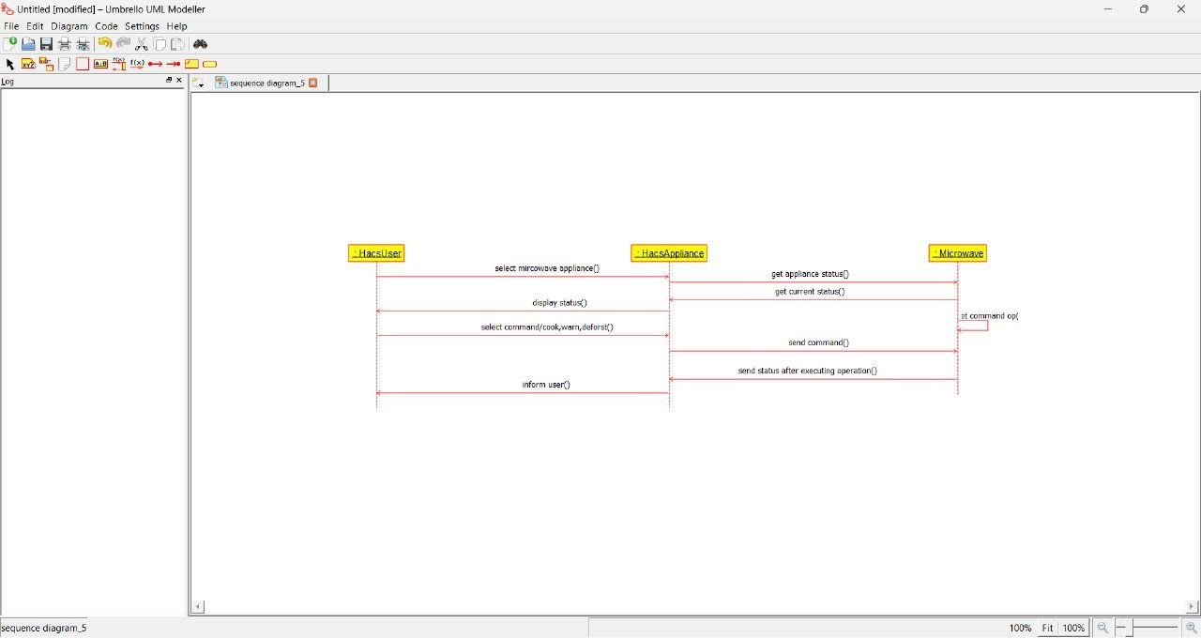

1. **LIBRARY MANAGEMENT SYSTEM USE CASE DIAGRAM:**

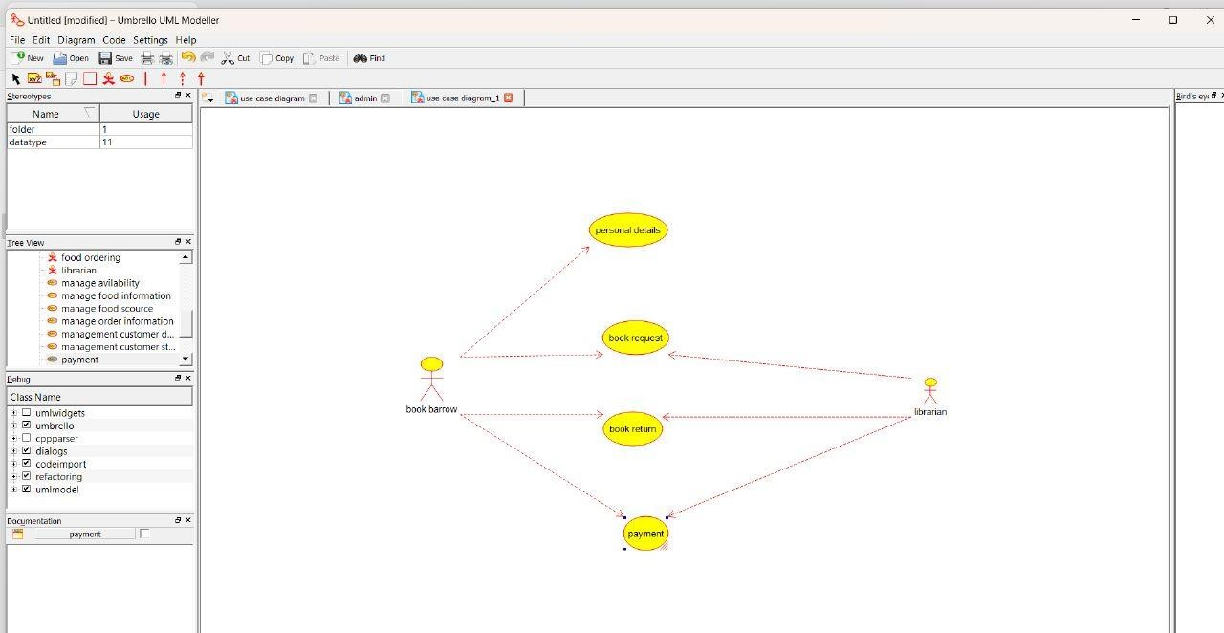

**ACTIVITY DIAGRAM:**

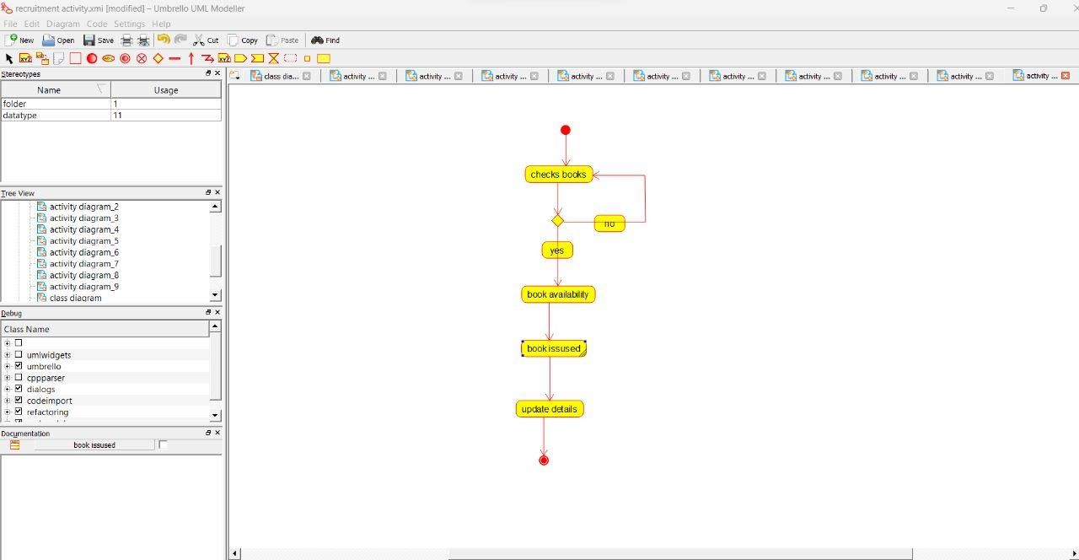

**SEQUENCE DIAGRAM:**

